

**PERSÉPOLIS**

Sheet Analysis and Classification for financial viability territorial entities

**Entity Type : municipality**

**Project: Smart Cities**

**Girardota[1]**: Colombian municipality, located in the Valley of Aburrá in the department of Antioquia . At 16 miles from Medellin 30 minutes by car.

**Financial Situation**

**Fiscal Category:** Category **3**

**State or Solvency Rating :** Green Semaphore

|  |  |  |
| --- | --- | --- |
| **Indicators of Financial Status** | **Limit** | **Result**  **2016** |
| **Solvency** | Less than or equal to 40% | **15,50%** |
| **Sustainability** | Less than or equal to 80% | **60,33%** |
| **Relationship : Interest Debt / Operating Savings** | Less than or equal to 40% | **15,50%** |



**Financial situation 2016 budget**

|  |  |
| --- | --- |
| **Year 2016 (USD)** | |
| **Income** | **10.612.800** |
| Tax revenue | 8.722.500 |
| No Income Tax | 818.100 |
| SGP (transfers of the nation) | 1.072.200 |
| **Expenses** | **4.271.700** |
| Personal expenses | 2.487.600 |
| General expenses | 834.600 |
| Transfers to municipal entities | 949.500 |
| **Service dedua** | **983.100** |
| **Investment ( approx without credits)** | **5.358.000** |

• 30 % of revenues are used in operating expenses

• 7% Debt Service

• 63 % Investment Projects

**Indebtedness**

Currently the municipality has credits with financial institutions such as Bancolombia , and Banco Pichincha IDEA . These reach the sum of 52.623.000, debt service has been fulfilled on time and the treasury of the municipality enjoys good reputation for timely payment 70% of these loans have been earmarked for purchase of land and 30% to finance roads.

These loans have been granted with terms between 5 and 12 years grace periods of 2 years, ending their payments as follows:

These loans have been granted with terms between 5 and 12 years thanks periods of 2 years, ending their payments as follows:

* Year 2017 : approx 6.000.000
* Year 2019 : approx 18.000.000
* Year 2025 : approx 15.000.000
* Year 2027 : approx 6.000.000

**Conclusions on the financial viability:**

1. The Municipality has healthy finances and is in qualification enables you to access debt.
2. The municipality meets solvency levels (15.5%) and Sustainability (60.33%), which space debt for 2016 would be approximately 3.300.000 USD (40% of current revenue). Source: Oswaldo Porras
3. Source of Payment and Guarantee: Your main source of income is tax Industry and Commerce (60% of own revenues), which is a free resource destination and which could leverage the credit guarantee. However, for use it will have to make adjustments to the budget to redirect resources that are going operating costs to investment.
4. Development Plan in its financial component provides for two credits each 650.000 USD for the years 2016 and 2017, which should take into account when making estimates as these would discount the value determined as borrowing capacity.
5. It is important to note that the Municipal Development Plan, has a structure that is broken from investment lines - components - programs - projects - and output indicators. This has an impact on the handling prowess that has to impact the objectives of the development plan through Smart Cities projects.
6. As an initial estimate, the Municipality could access credit at 2.300.000 USD for the Smart Cities project leverage within 10 years, with a guarantee that would be structured based on the pledge of 4% approx. Tax Industry and Commerce.

**Typing**

**Population:**

* 2015 Population : 52,240 habitants Most African descent .
* 51% female 49 % male .
* 10% of 0-5 years , childhood
* 12% of 6-12 years , children
* 29 % adolescence and youth
* 49 % adult and elderly ( with upward trend )

**Situación Política**

**Mayor:**

* Yan Bladimir Jaramillo Garcia [2]
* Public Employees: 129 funcionarios vinculados
* Administrative structure 10 secretariats, 2 decentralized entities and 4 sub- secretariats

**Town Council:**

* 13 Councils
* Majorities; Partido de la U y Partido Conservador

**Location and Geography**

**South América – Colombia - Antioquia**

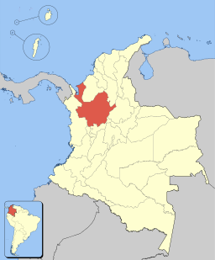

**Antioquia – Municipios - Girardota**

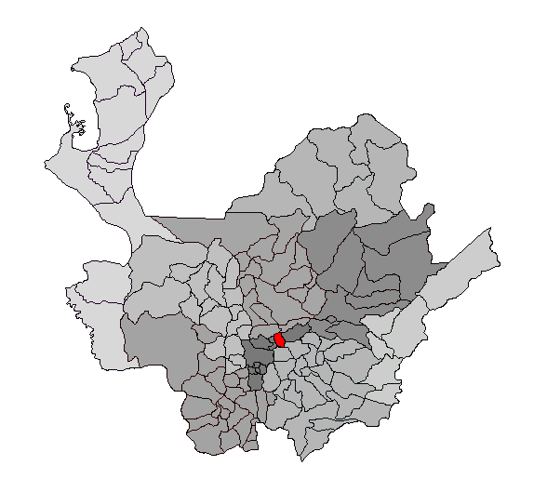

**Girardota – Veredas – Casco Urbano**

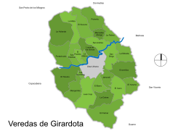

Its territory is mountainous Cordillera is crossed by the Medellín river . It is composed as follows:

• District 17 neighborhoods

• Zone 25 rural villages

1. Code CGN: 210805308
2. Elección: Partido de la U en coalición con el Partido Liberal Colombiano y en alianza con el Movimiento Alternativo Indígena y Social (Mais), Cambio Radical, Partido Alianza Verde y el apoyo de disidentes o matices del Partido Conservador